Integrated Approach for Flood Modeling using Arc GIS, HEC-GeoRAS – A Case Study on Purna River of Navsari District of Gujarat State
¹Azazkhan I. Pathan ²Dr. Pankaj J. Gandhi ³Dr. P. G Agnihotri
^{1,2}Research Scholar ³Professor (Water Resources Engineering)
^{1,2,3}Department of Civil Engineering
^{1,2,3}Sardar Vallabhbhai National Institute of Technology, Surat, Gujarat, India
Abstract

This research work indicates the advancement of flood modeling using Arc GIS and HEC GeoRAS software in the field of water resources engineering and flood management. The methodology is applied to Purna River, Navsari district, Gujarat, India. In this research, we have used satellite, topographic, contour map, hydraulic and hydrologic data for flood modeling. In this paper first part of the methodology followed by preprocessing data involved to develop DEM (Digital Elevation Model) using contour data, Georeferencing, and Shapefile in Arc GIS software. After that, these all geometry data are imported into HEC RAS through HEC GeoRAS interface in ArcGIS environment. This research demonstrates the flood mapping approach for disaster authorities by modeling using past data required in HEC-RAS. This methodology is also used to develop flood risk map in Arc GIS environment for the study area. From this research, we can conclude that with GIS technology combine with the computed model the flood mitigation is very beneficial for disaster management after mapping the extent of the flood.
Keyword- Arc GIS, HEC-RAS, HEC GeoRAS, Flood, D. E. M, G.I.S, R. S __________________________________________________________________________________________________

Introduction
Flood and its impact on the communities.
A flood can be characterized as any near measure of high water stream that overtops the non-characteristic or regular banks in any part of a waterway or stream. At the point when a bank is overtopped, the water dinners over the flood plain zone and for the most part turns into a risk to individuals and society. Generally, flood is likely the most expansive, rehashing, calamitous and frequent exposure of the world. Our India is a standout amongst the most detectably terrible flood impacted nations on the planet, being second on the planet after Bangladesh and records for 1/fifth of in general passing incorporate on account of flood India. Flood is a natural disaster cause damage to people and lives surrounding region. Hazarikad and Samarakoond (2010) present that Gin-Ganga river and Kalu-Ganga river, Sri Lanka locate the ocean between Gulf of Mannar and Bay of Bengal, these rives are experiencing two monsoon season due to high wind flow on the river. A surrounding region having a good land pattern for crop and agriculture use, Sri Lanka Disaster management authorities are working to mitigate the flooding event. Dhruvesh and Mrugen (2010) demonstrate that Surat is fast growing city of India and it is located near River Tapi, He develops the Remote sensing (RS) and Geographical Information system (GIS) because of Surat city of India is situated near River Tapi, a watershed water enter in to city with minimum time period due to high rainfall during monsoon season results in flooding, its damages losses of lives and valuable properties. They use Geography techniques to mitigate the flood because water is entering into Surat city during high rainfall during monsoon. Zerger and Wealands (2004) explain that cyclone, industrialization, urbanization are the main factor to responsible for flood and it is lead to damage to valuable properties surrounding the region in North Australia. Lee and Choi (2003) demonstrate that the central part of Korea is highly vulnerable to flood due to typhoons and high rainfall cause dame loss of lives. Disaster authorities of Korea develop a flood mitigation plan to minimize the flood. Debasis and Bipul (2012) examine that the wetland is also a major factor for the occurrence of flooding, the Remote sensing (RS) and Geographical Information system (GIS) technology are using for natural drainage in the wetland.

Study area
The study area is the Purna River basin near Navsari district is located in the southern part of Gujarat State, India. It is one of the most vital districts in Gujarat State separated from Valsad district. Navsari district lies between Latitude 20°32’ & 21°05’ North and Longitude 72°42’ & 73°30’ East It are limited by Surat district in the north, Dangs district in the east. Valsad region in the South and the Arabian Sea in the west region. Navsari district has a geographical area of about 2210.97 km². Map of Navsari district in Gujarat, India is shown in (Figure 1).The River Purna rise in the Saputara hills of the Western Ghats near the village of Chinchi in Maharashtra. The length of the river from its starting point to discharge in the Arabian Sea is about 180 km. The main branches of the Purna River are Dhodarnala, Barnala, Nagihparnala, Zankari River, Girna River, and Dumas khadi. The catchment area of the Purna basin is 2431 km². The basin lies between 720º 45’ to 740 º 00’ East zone longitudes and 200º 41’ to 210º 05’ North zone latitude and Basin map of Purna are shown in (Figure 2).
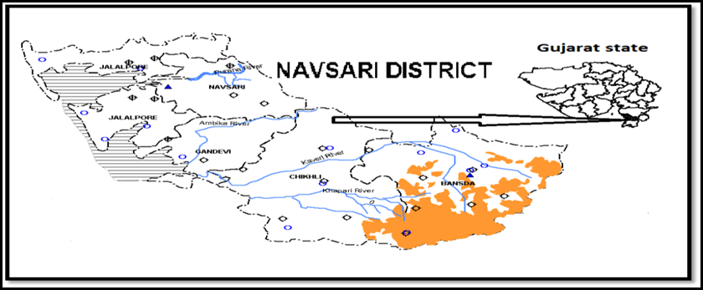
Fig. 1: Navsari district, Gujarat, India
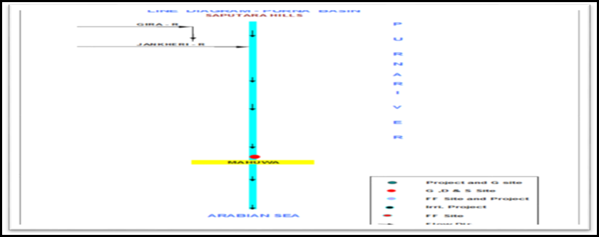
Fig. 2: Line diagram of Purna River (Sources: www.cwc.nic.in)

Data used
Dhruvesh and Mrugen (2010) demonstrate that satellite data are very beneficial to detect the flood extent to mitigate the flood activities. Smith (1997) used active and passive remote sensing data to determine the stage, discharge and water surface area of River. Daxikar, et al. (2008) were used GIS data set (e.g. TIN - triangular irregular network and GRD image), also use census population, Orthophotography, land use data which can be used in ArcGIS software for flood mapping and it is very advantageous for disaster authorities to take a decision. Topography data are like a contour map of 1:10000 scales, land use a land cover image, bathymetric cross-section data of Purna basin obtain from irrigation department Navsari district. Water level and discharge data obtain from Central Water Commission (CWC) Surat.

Methodology
The methodology consists of data collection and data required for River flood modeling. Based on Hydraulic and hydrologic data use in Arc GIS and HEC-RAS environment a conceptual model develops as in (Figure 3)
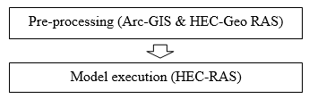
Fig. 3: Conceptual Diagram of Methodology

Arc-GIS software
ArcGIS is a geographical information system (GIS) for working with maps and geographic information. It is used for creating and using maps, compiling geographic data, analyzing mapped information, sharing and discovering geographic information, using maps and geographic information in a range of applications, and managing geographic information in a database.

HEC-GeoRAS
HECGEO-RAS is a set of procedures, tools, and utilities for processing geospatial data in ARC-GIS using a graphical interface. The interface allows the preparation of geometric data for import into HEC-RAS and processes simulation results exported from HEC-RAS

HEC-RAS (Hydrologic Engineering Center River Analysis System)
HEC-RAS is a known to program that model the hydraulics of water flow through natural rivers and other channels. HEC-RAS is a computer program for modeling water flowing through systems of open channels and computing water surface profiles. HEC-RAS finds particular commercial application in floodplain management.

Pre-processing (Arc-GIS & HEC-GeoRAS)
For the pre-processing of the data, software HEC-GeoRAS and ArcGIS is used. HEC-GeoRAS is an extension used with Arc GIS. It is specially designed to process geospatial data for use with the Hydrological Engineering Center River Analysis System (HEC-RAS). It allows the creation of a HEC-RAS import file containing geometric attribute data from an existing digital elevation model (DEM) and complementary data sets. The results exported from HEC-RAS will be further processed in the GIS environment. By means of HEC-GeoRAS, an import file have been created the geometry of the discharging watersheds into the floodway.
Following steps are followed by Arc GIS software.
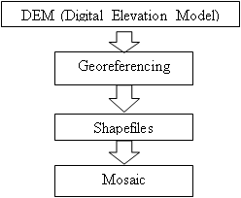
Fig. 4: Conceptual Diagram for Pre-processing Methodology
- Georeferencing: is the process of assigning spatial coordinates to data that is spatial in nature.
- Shapefile: format is a popular geospatial vector data format for geographic information system (GIS) software.
- Mosaic: Mosaic is useful when two or more adjacent raster datasets need to be merged into one entity.

HEC-RAS - Model Execution
In this phase, the geometric data created are imported in the HEC-RAS. Then add all data required for model execution process in HEC-RAS. (Figure 5) indicate the HEC-RAS import file from ArcGIS environment, there cross sections are provided called as HEC GeoRAS geometry in ArcGIS environment to detection of flood for a particular cross-section.

Result and discussion
As per contour information, Digital Elevation Model (DEM) creates which gives 30-meter resolution and it is exactly at a satisfactory limit. After that Georeferencing procedure is completed, at that point after the shapefile and the mosaic procedure has been done which gives in the form of a map. This map demonstrates the elevation height of the area under study. After that HEC Geometry information must be characterized in Arc GIS condition. At long last, This Arc GIS information is exported to HEC-RAS for flood modeling. Results got from ArcGIS and in HEC-RAS are as in (Figure 5, Figure 6, and Figure 7).
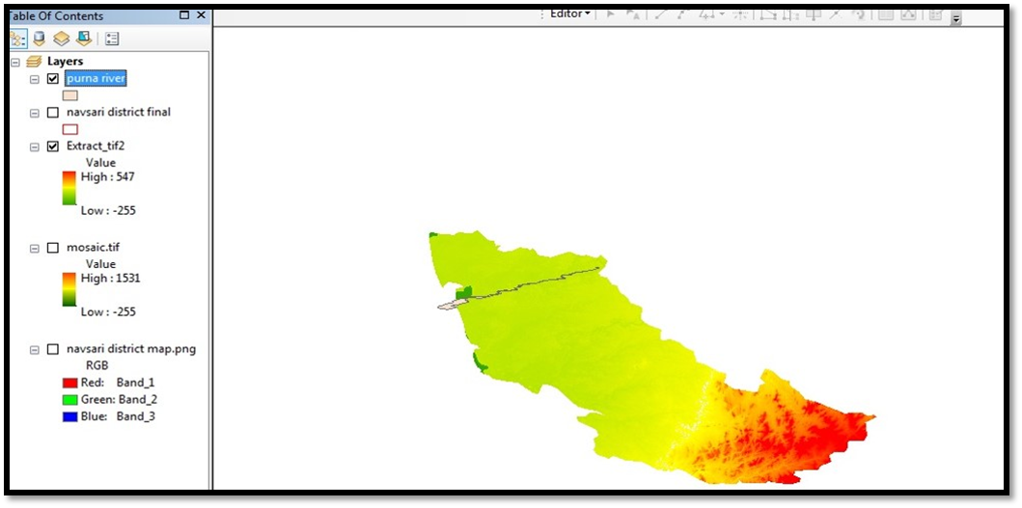
Figure 5. Georeference shapefile of Navsari district and Purna River, Gujarat, India
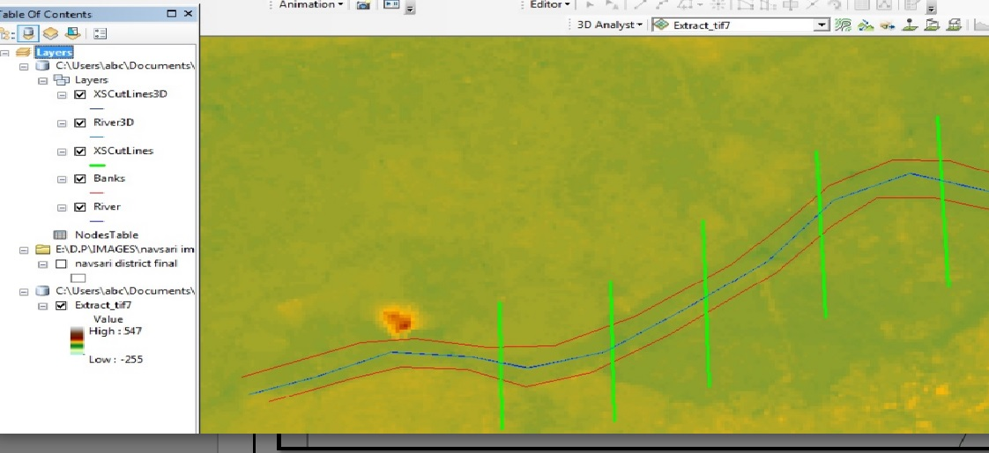
Figure 6. HEC GeoRAS Geometry window in ArcGIS
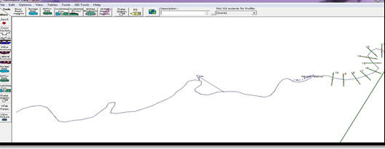
Fig. 7: Import GIS database file in HEC-RAS

Conclusion
The examination contemplates shows the utility of Arc GIS and HEC-RAS combined utilized for flood modeling. Future extension lies to measure the flood at each cross section by applying hydraulic, hydrologic data and boundary condition in HEC-RAS environment for the study area. More Besides, we can propose the development bank close to the stream of the study area to disaster authorities and to create floodplain map, flood hazard map for Navsari district under varying scenarios.

References
Brivio PA, Colombo R, Maggi M, et al (2002) Integration of remote sensing data and GIS for accurate mapping of flooded areas. International Journal of Remote Sensing, 23 (3), 429-441.
Daxikar A, Hillier T, Makarem F, et al (2008) Application of GIS technology in coastal flood hazard mitigation. Solutions to Coastal Disasters Congress 2008. April 13-16, 2008, Turtle Bay, Oahu, Hawaii, United States (pp. 396-409).https://doi.org/10.1061/40968(312) 36.
Debasis D, Bipul T (2012) Hydro-Geomorphological Analysis of a Water Logged Area of South Tripura District Using RS and GIS Technology, World Environmental and Water Resources Congress 2012, May 20-24, 2012, Albuquerque, New Mexico, United States, https://ascelibrary.org/doi/10.1061/9780784412312.388
Hazarikad MK, Samarakoond L (2010) Application of remote sensing and GIS for flood risk analysis: A case study at Kalu-Ganga River, Sri Lanka. International Archives of the Photogrammetry, Remote Sensing and Spatial Information Science, 38(Pt 8), 110-115.
Islam MM, Sado, K (2000) Development of flood hazard maps of Bangladesh using NOAA-AVHRR images with GIS. Hydrological Sciences Journal, 45(3), 337-355.
Jha AK, Bloch, R, Lamond, J et al (2012) Cities and flooding: a guide to integrated urban flood risk management for the 21st century. The World Bank.
Lee S, and Choi U (2003) Development of GIS-based geological hazard information system and its application for landslide analysis in Korea. Geosciences Journal, 7(3), 243-252.
Merwade V, Cook A, Coonrod J (2008). GIS techniques for creating river terrain models for hydrodynamic modeling and flood inundation mapping. Environmental Modelling & Software, 23(10-11), 1300-1311.
Patel DP, Dholakia MB (2010) Feasible structural and non-structural measures to minimize the effect of flood in lower Tapi basin. WSEAS Trans Fluid Mech, 3, 104-121.
Pradhan B (2010) Flood susceptible mapping and risk area delineation using logistic regression, GIS and remote sensing. Journal of Spatial Hydrology, 9(2).
Roy SK, Sarker SC (2016) Integration of Remote Sensing Data and GIS Tools for Accurate Mapping of Flooded Area of Kurigram, Bangladesh. Journal of Geographic Information System, 8(02), 184.
Sahoo SN, Sreeja P (2015) Development of Flood Inundation Maps and quantification of flood risk in an Urban catchment of Brahmaputra River. ASCE-ASME Journal of Risk and Uncertainty in Engineering Systems, Part A: Civil Engineering, 3(1), A4015001.
Smith LC (1997) Satellite remote sensing of river inundation area, stage, and discharge: A review. Hydrological processes, 11(10), 1427-1439.
Zerger A, Wealands S (2004) Beyond modelling: linking models with GIS for flood risk management. Natural Hazards, 33(2), 191-208.

